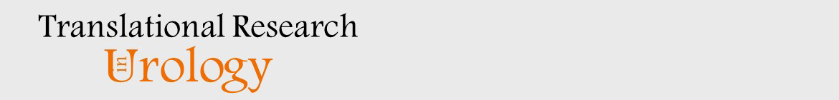

AUTHORSHIP FORM

Manuscript title: Iatrogenic Glans Penis Injury During Circumcision: Clinical Spectrum, Mechanisms, and Medicolegal Implications—A Systematic Review
Running Head: Iatrogenic Glans Injury During Circumcision

By signing and filling this form, the corresponding author certifies that each author has met all criteria below (A, B, C, and D) and indicates each author general and specific contributions by listing his or her name next to the relevant section.

A. I certify that
- The manuscript is original and has not submitted to another journal for publication, has not been published elsewhere
- I will provide the data or will contribute fully in providing and obtaining the data on which the manuscript is based for examination by the editors or their assignees, if requested.
- Every author has agreed to allow the corresponding author to serve as the primary correspondent with the editorial office, to review the edited manuscript and proof.
B. Each author has given final approval of the submitted manuscript.
C. Each author has participated sufficiently in the work to take public responsibility for the
whole content.
D. Each author qualifies for authorship by listing his or her name on the appropriate line of
the categories of contributions listed below. List appropriate author next to each section.

Each author must be listed in at least one field. More than one author can be listed in each field.

- conception and design — Abdul Hakim Nitiprodjo; Andi Muhammad Maulana; Titik Kusumawinakhyu
- acquisition of data — Abdul Hakim Nitiprodjo; Andi Muhammad Maulana; Prima Maharani Putri
- analysis and interpretation of data — Abdul Hakim Nitiprodjo; Prima Maharani Putri; Titik Kusumawinakhyu; Tegar Fitriyana S. Karso
- drafting of the manuscript — Abdul Hakim Nitiprodjo; Andi Muhammad Maulana; Prima Maharani Putri
- critical revision of the manuscript for important intellectual content — Abdul Hakim Nitiprodjo; Andi Muhammad Maulana; Prima Maharani Putri; Titik Kusumawinakhyu; Tegar Fitriyana S. Karso
- statistical analysis — Not applicable; no quantitative meta-analysis was performed.
- obtaining funding — Not applicable.
- administrative, technical, or material support — Andi Muhammad Maulana; Prima Maharani Putri
- supervision — Titik Kusumawinakhyu; Tegar Fitriyana S. Karso
- no additional contributions — Not applicable.
- other (specify) — Study screening: Abdul Hakim Nitiprodjo and Andi Muhammad Maulana; data extraction: Andi Muhammad Maulana and Prima Maharani Putri; JBI critical appraisal: Titik Kusumawinakhyu and Tegar Fitriyana S. Karso; medicolegal evidence synthesis: Abdul Hakim Nitiprodjo, Prima Maharani Putri, and Tegar Fitriyana S. Karso.

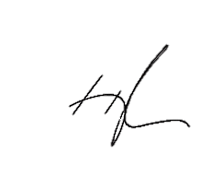
Corresponding author name: Abdul Hakim Nitiprodjo

Signature: ____________________ Date: 08 September 2026

